Ex.no:6 | DATA VISUALIZATION USING POWER BI

Aim:
To perform data analysis, data preparation, and advanced data visualization using Power BI on the Credit Card Fraud Detection dataset, and to create interactive charts, cards, and slicers for analyzing transaction amounts, fraudulent transactions, legitimate transactions, transaction patterns, and fraud distribution.

Algorithm:

1. Importing Dataset
- Open Power BI Desktop.
- Select Home → Get Data → Text/CSV (or Excel, depending on your dataset format).
- Select the Credit Card Fraud Detection dataset.
- Click Load.

2. Data Cleaning
- Select Home → Transform Data.
- Check for and remove duplicate records.
- Handle missing or null values.
- Check and correct the data types of all columns.
- Ensure transaction-related columns such as Time, Amount, and Class have appropriate data types.
- Click Close & Apply.

3. Fraud vs Legitimate Transaction Distribution
- Select a Donut Chart.
- Add Class to the Legend.
- Add Class to Values.
- Set the aggregation to Count.
- Rename the categories appropriately:
  - 0 = Legitimate Transaction
  - 1 = Fraudulent Transaction
- Give the title Fraud vs Legitimate Transaction Distribution.

4. Total Transaction Amount by Transaction Type
- Select a Clustered Column Chart.
- Add Class to the X-axis.
- Add Amount to the Y-axis.
- Set Amount to Sum.
- Give the title Total Transaction Amount by Transaction Type.

5. Average Transaction Amount by Transaction Type
- Select a Clustered Bar Chart.
- Add Class to the Y-axis.
- Add Amount to the X-axis.
- Set Amount to Average.
- Give the title Average Transaction Amount: Fraud vs Legitimate.

6. Transaction Amount Analysis
- Create a Scatter Chart.
- Add Time to the X-axis.
- Add Amount to the Y-axis.
- Add Class to the Legend.
- Give the title Transaction Amount Pattern Over Time.
This visualization helps identify patterns between fraudulent and legitimate transactions.

7. Fraud Transactions Over Time
- Select a Line Chart.
- Add Time to the X-axis.
- Add the Count of Class to the Y-axis.
- Use Class as a filter and select only 1 (Fraudulent Transactions).
- Give the title Fraudulent Transactions Over Time.

8. Dashboard Creation
- Create DAX measures for:
  - Total Transactions
  - Total Fraud Transactions
  - Total Legitimate Transactions
  - Total Transaction Amount
  - Average Transaction Amount
  - Fraud Percentage
- Add Card visuals to display these important values.
- Add slicers for:
  - Class (Transaction Type)
  - Time
  - Amount Range, if required.
- Arrange all charts, cards, and slicers properly to create an interactive Credit Card Fraud Detection Dashboard.
- Save the Power BI file with the .pbix extension.

Output
Clustered Bar Chart:
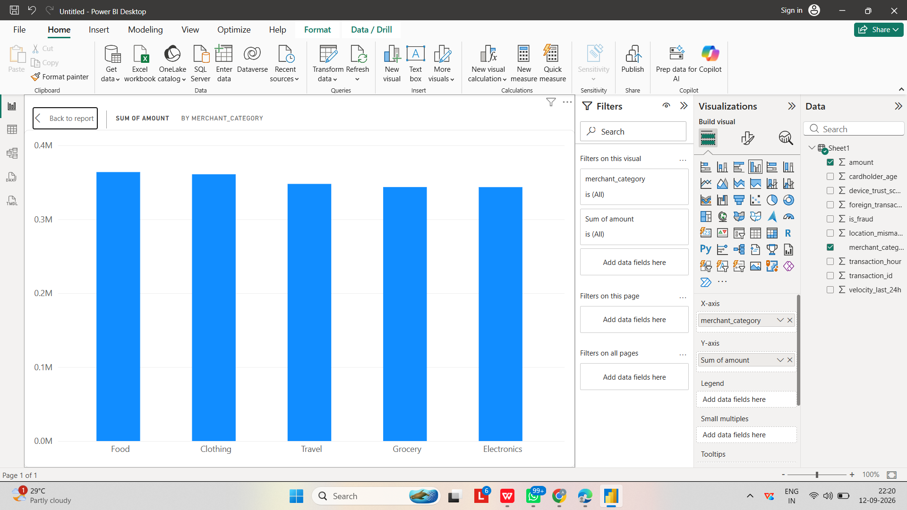

Pie Chart:
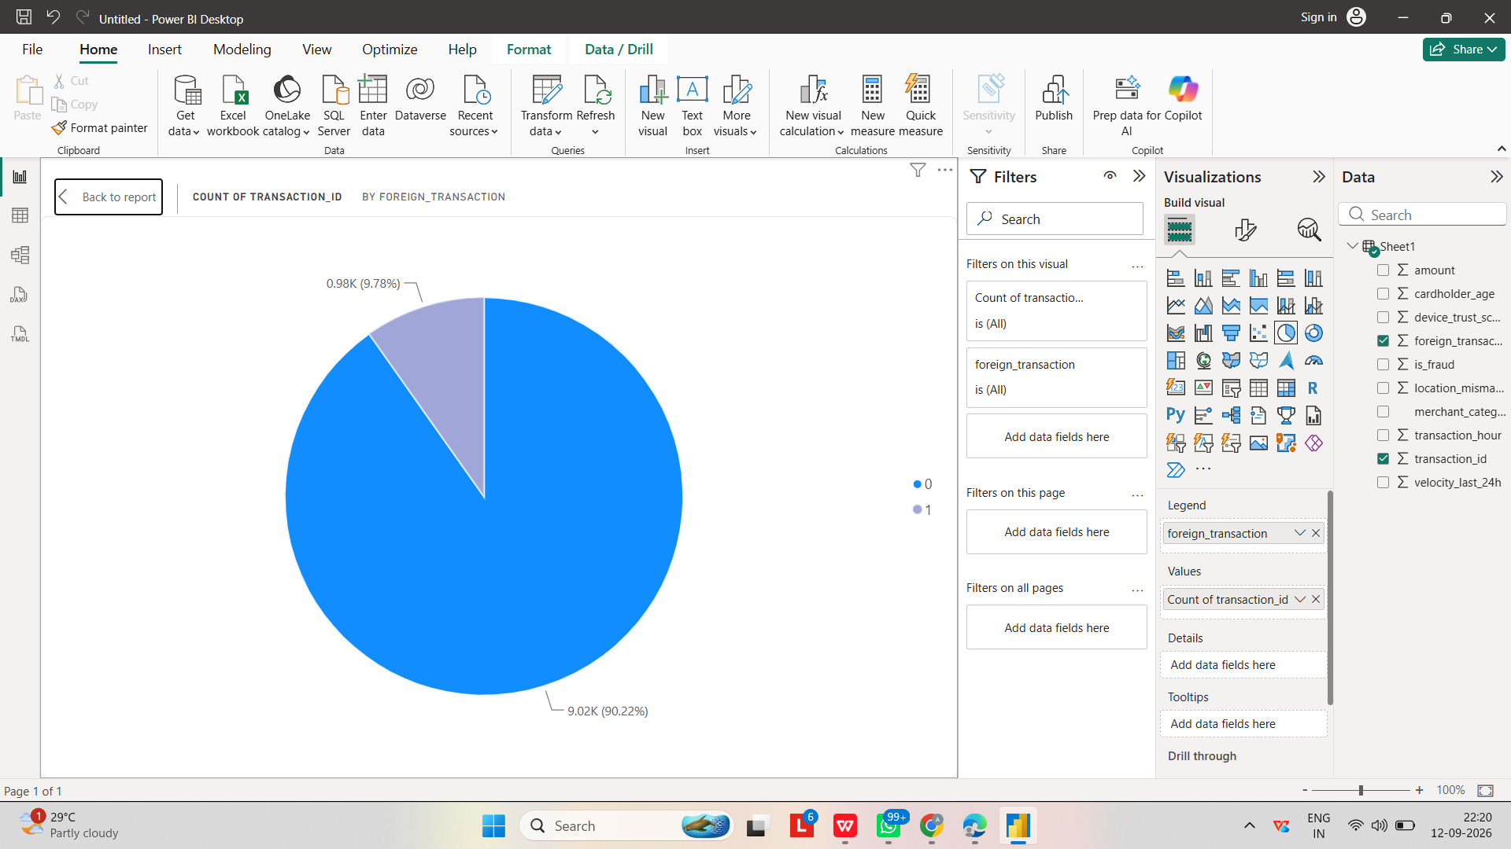
Donut Chart:
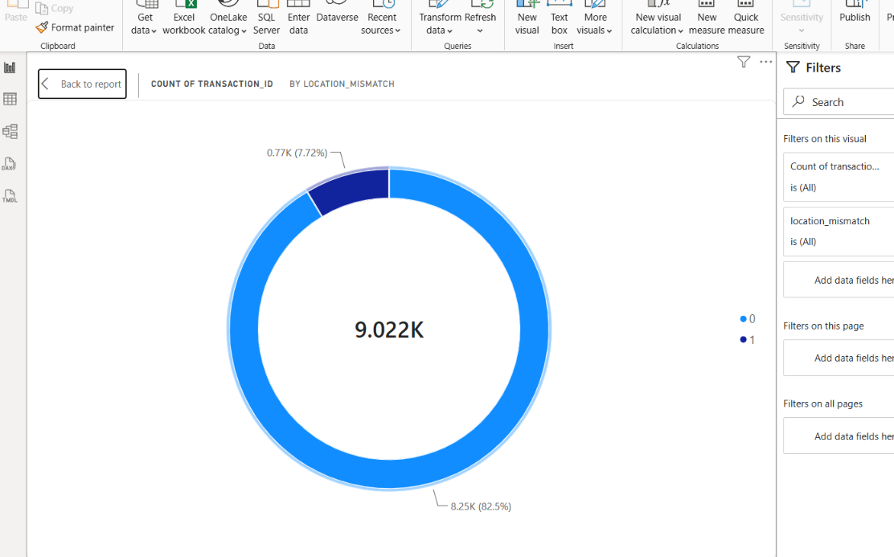

Line Chart:
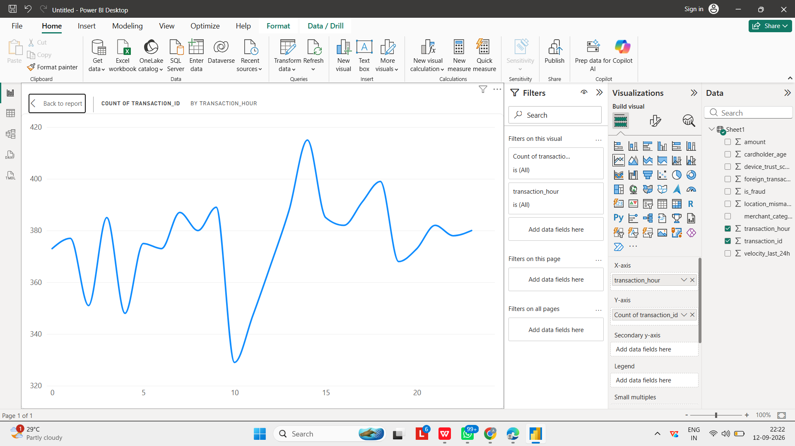
Scatter Chart:
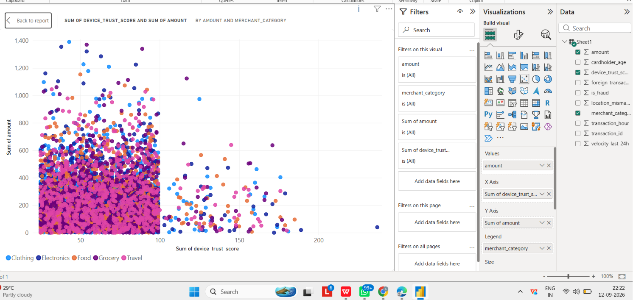

Dashboard Creation:
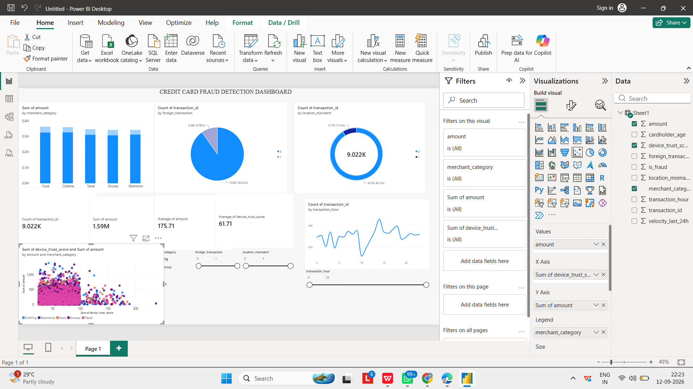

Result:
The Credit Card Fraud Detection dataset was successfully imported, cleaned, and analyzed using Power BI. Various interactive visualizations such as bar charts, column charts, donut charts, line charts, scatter charts, cards, and slicers were created to analyze legitimate and fraudulent transactions.
The dashboard provided insights into fraud distribution, transaction amounts, average transaction values, and transaction patterns over time. DAX measures and interactive filters helped users explore the dataset effectively.
Thus, an interactive Credit Card Fraud Detection Dashboard was successfully created and used to identify and analyze patterns related to fraudulent credit card transactions.

Result:

